**DEPARTMENT OF INFORMATION TECHNOLOGY**

**Course: Data Mining & Business Intelligence Lab (ITL601)**

**B.Tech. (Information Technology) – Semester VI**

**Academic Year: 2023-24 (Even Semester)**

**PRACTICAL 9**

**Aim:** Detailed study of BI Tools such as: Pentaho, Tableau, QlikView, PowerBI.

**Lab Objective:** To identify and compare the performance of business.

**Theory:**

Business Intelligence (BI) tools are software applications used to analyze, process, and present data to help organizations make informed decisions. These tools enable users to collect, store, and analyze data from various sources, transforming it into meaningful insights through visualizations, reports, and dashboards. BI tools like Power BI, Tableau, QlikView, and Pentaho offer features such as data integration, data visualization, ad-hoc reporting, and predictive analytics to support decision-making processes.

They play a crucial role in helping businesses understand trends, patterns, and relationships within their data, ultimately leading to improved operational efficiency and strategic planning. BI tools are essential for organizations looking to leverage data-driven insights to gain a competitive edge in today's data-driven business landscape.

**BI Tools**

**Pentaho:**

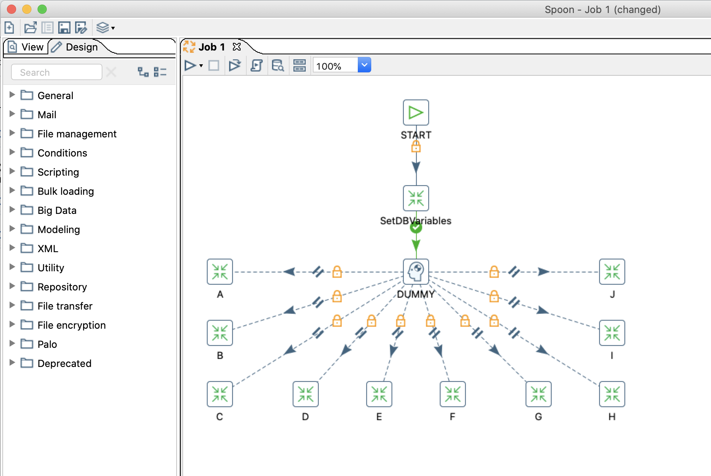

Pentaho is a comprehensive business intelligence software that excels in data integration, reporting, OLAP, data mining, and ETL (extraction, transformation, loading). It offers an enterprise edition with additional features available through a yearly subscription, enhancing its capabilities for businesses dealing with data. Pentaho's user-friendly interface allows business managers to communicate, broadcast, and access data intuitively.

The software facilitates robust data integration and collaboration, supporting various data types like Excel and Hadoop. With features like OLAP, ad hoc reporting, cloud analytics, and predictive analysis, Pentaho empowers users to generate insightful reports, create intuitive dashboards, and derive new insights from data mining processes.

**Tableau:**

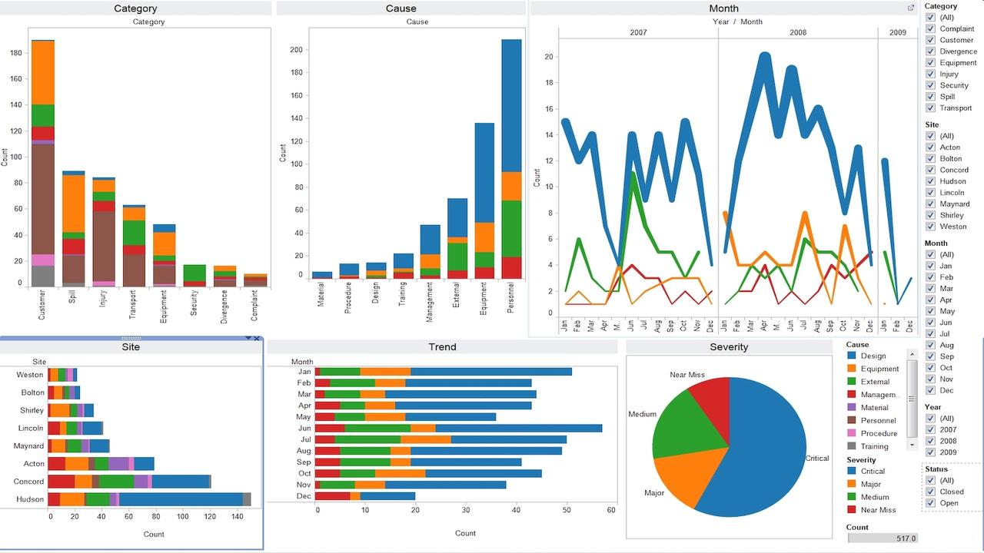

Tableau is a powerful data visualization tool widely used in the business intelligence industry. It transforms raw data into understandable formats without requiring technical knowledge or coding skills. Tableau's strength lies in its ability to quickly analyze data, producing visualizations in the form of dashboards and worksheets. By enabling users to create interactive dashboards that offer actionable insights, Tableau enhances decision-making processes.

Its features include roll-back options, body views for licensing, mobile services, JavaScript enhancements, and documentation capabilities. Tableau stands out for its advanced analytics features like predictive analytics and geospatial analysis, making it a top choice for organizations needing strong visualization capabilities and complex data analysis.

**QlikView:**

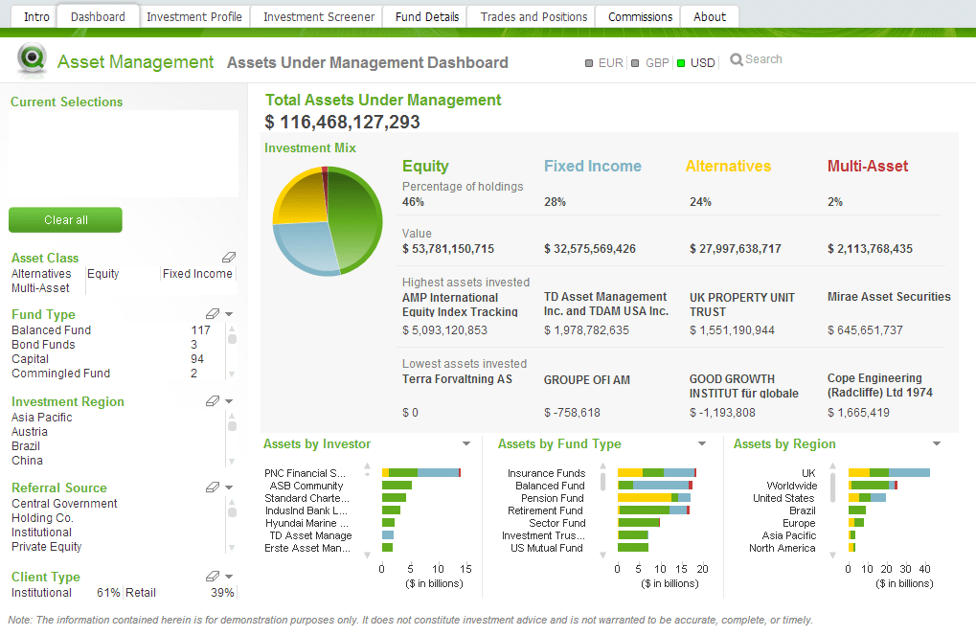

QlikView is a robust business intelligence tool known for its powerful data integration capabilities and user-friendly interface. It is designed with a robust architecture that includes components like client, publisher, and server, enabling scalability and load balancing for consistent business operations across various data types and scales. QlikView's QIX Engine enhances data analysis by highlighting relevant data in reports through color changes, simplifying the interpretation of data.

While QlikView requires programming skills for operation, it excels in data access speed due to its in-memory storage, making it a preferred choice for users with a bit of data science background. The tool is particularly strong in customizable dashboards, report sharing, collaboration, drill-down analysis, and formatting capabilities, offering dynamic insights for decision-making processes.

**PowerBI:**

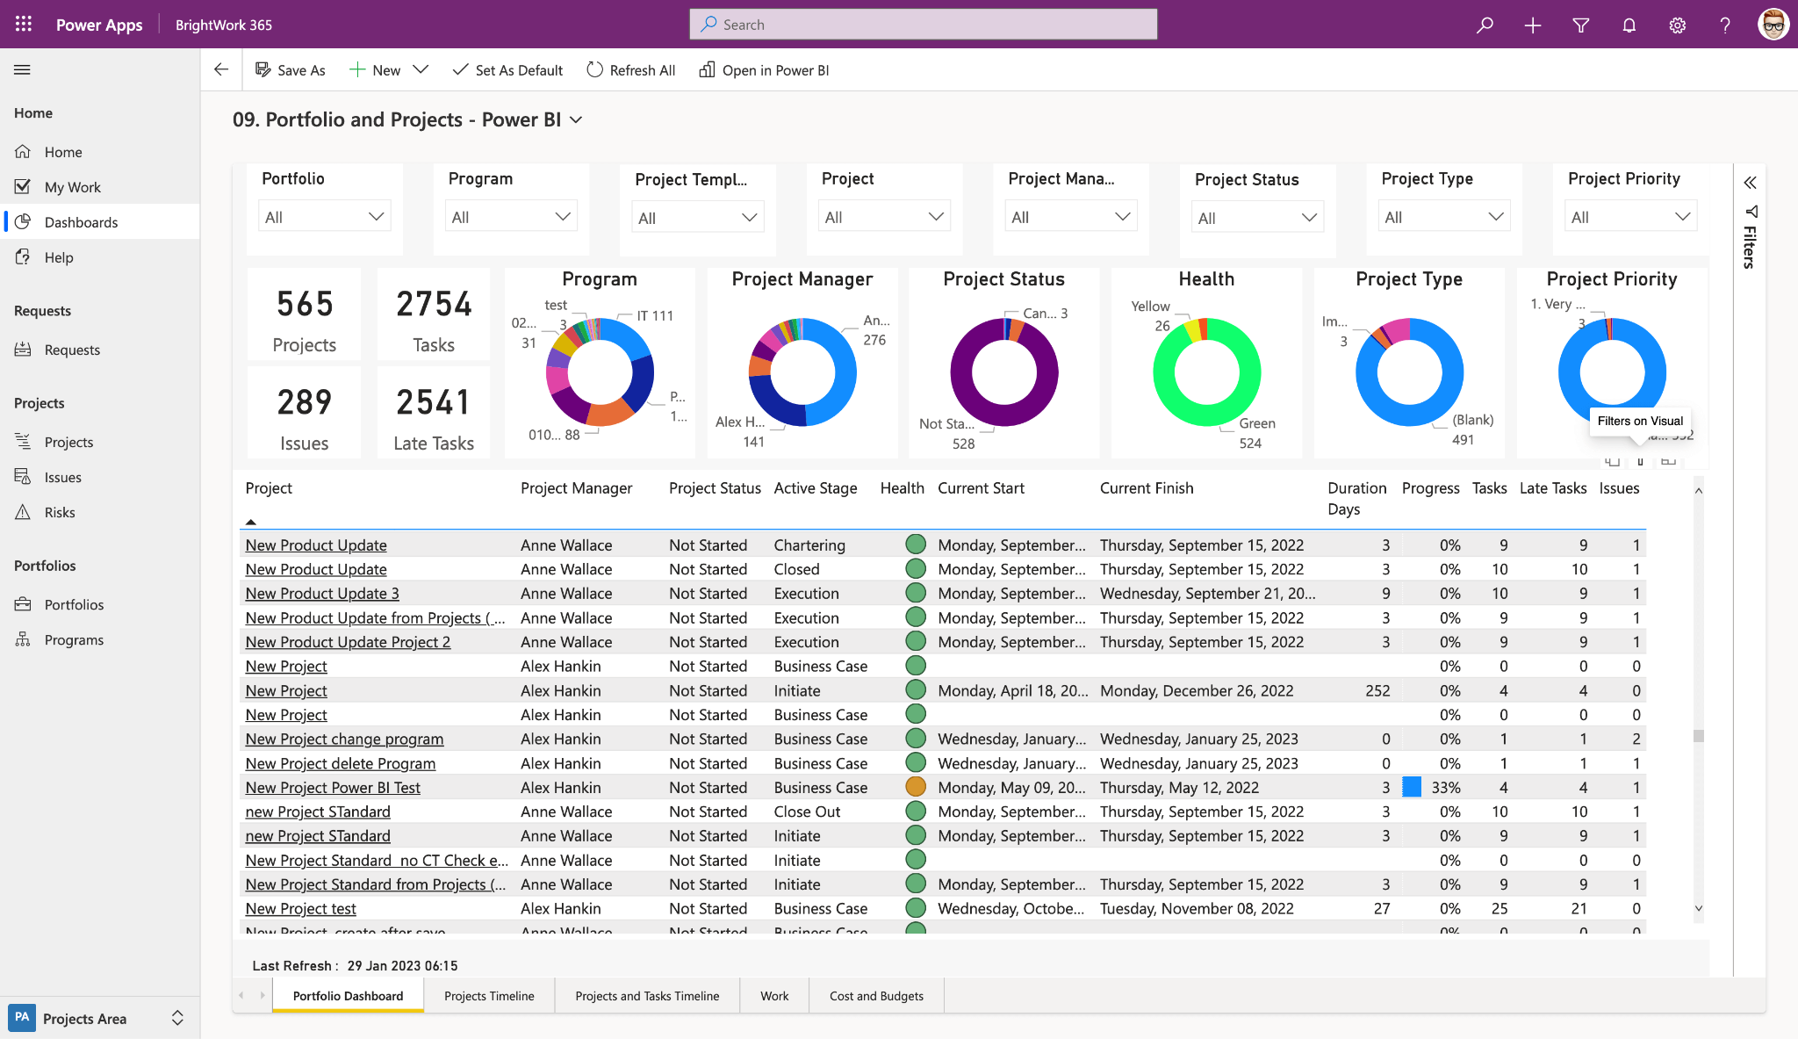

PowerBI is a leading business intelligence tool that stands out for its user-friendly interface, intuitive features, and strong data management capabilities. It is known for its ease of learning, with a simple process that requires basic Excel knowledge, making it accessible to a wide range of users. PowerBI excels in ad-hoc reporting, access control, analytics, security, mobile capabilities, and embedding, offering a comprehensive solution for data visualization and analysis.

The tool's integration capabilities are impressive, connecting with various Microsoft technologies and external platforms like MySQL, Google Analytics, Oracle, and more. PowerBI's pricing structure, with a free basic version and commercial options, makes it an attractive choice for small to mid-sized businesses. Overall, PowerBI is considered a user-friendly tool with advanced features for data analysis and visualization.

**Conclusion:**

We learnt about Frequent Mining Algorithms and their different types. We also implemented the Apriori algorithm in Python, generating strong association rules for a given problem.

**Lab Outcome:** Apply BI to solve practical problems: Analyze the problem domain, use the data collected

in enterprise apply the appropriate data mining technique, interpret and visualize the results

and provide decision support.

**Submitted Details -**

**Name of Student: Parth Malviya**

**Roll No.: 22**

**Date of Performance:**

**Date of Submission:**